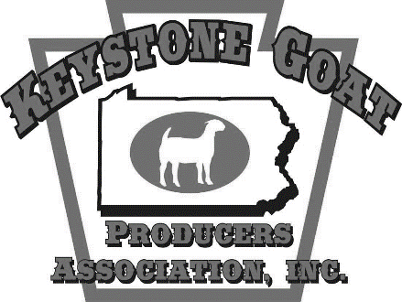

February 21, 2024
The Keystone Goat Producers Association, Inc. (KGPA) is seeking sponsors for our 2024 KGPA Show Series. This series is a points-based awards program focused on youth exhibitors that runs throughout the year and cumulates at a year-end awards banquet in November. We are still working to put together the list of shows that will be included in the series this coming year, however the 2023 series consisted of 10 shows, more than 125 participants, and over 300 animals from Pennsylvania, Delaware, Maryland, Virginia, West Virginia, and New York.
There are four junior divisions in the series. The market goat, market lamb, youth commercial doe, and Junior American Boer Goat Association (JABGA) divisions are open to all youth under the age of 21. The KGPA is proud to support these juniors and encourage their involvement in the agriculture industry. Many of these youth are current 4-H and/or FFA members. We also recognize participants in the American Boer Goat Association (ABGA) sanctioned shows, which are open to exhibitors of all ages.
Attached you will find information regarding our tiered sponsorship program. We greatly appreciate any and all support you are able to provide for the 2024 KGPA Show Series. Please feel free to reach out for more information or with any questions.
Sincerely,
Keystone Goat Producers Association Board of Directors
www.keystonegoatproducers.net
keystonegoatproducers@gmail.com

2024 KGPA Show Series
*More shows will be added*
Battle at Berkeley Interstate Blitz Souder Stock Clinic and Jackpot Keystone Classic
May 4, 2024 May, 12, 2024 June 2, 2024 June 21-23
Martinsburg, WV Clearbrook, VA Newville, PA Elizabethtown, PA
Susquehanna Valley Showdown
June 29-30
Lebanon, PA

Firecracker Classic
July 5, 2024
Clearbrook, VA
Keystone Summer Finale
August 31-September 1, 2024
Elizabethtown, PA
KGPA Show Series Banquet
November 16, 2024
Ono Volunteer Fire Company
Ono, PA
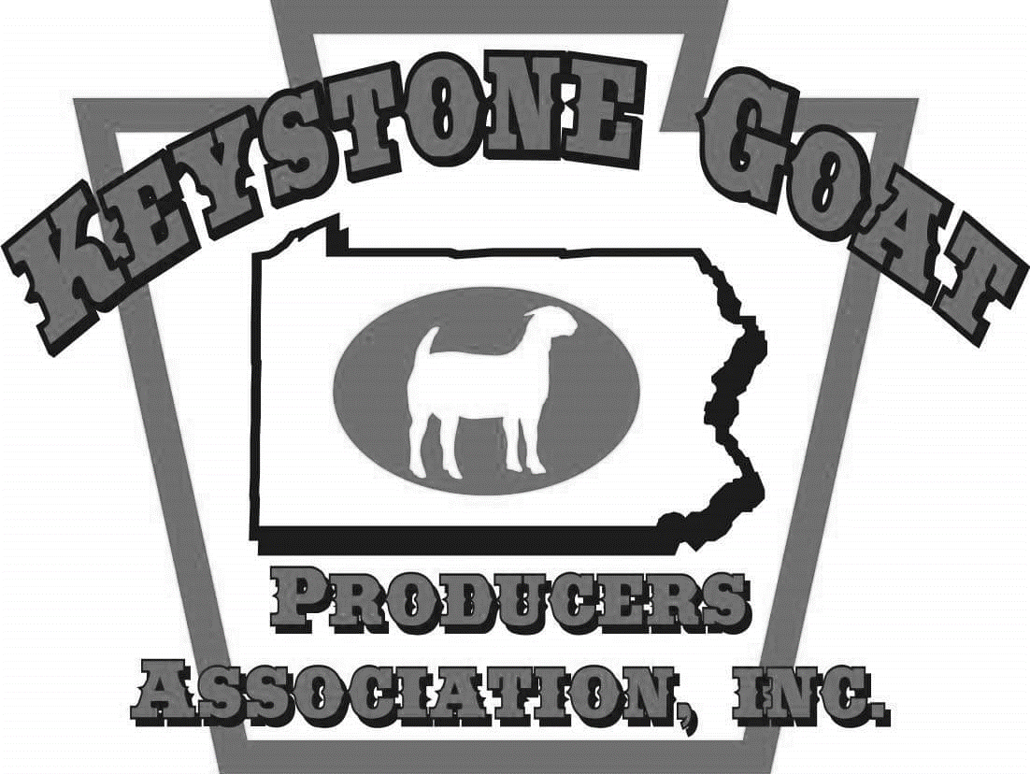
2024 KGPA Show Series Sponsorship

Platinum Level Sponsor: $500
- ‘Sponsor Spotlight’ on KGPA Facebook page, website, and newsletter
- Waived vendor fee at KGPA shows
- Free ticket to KGPA show series banquet
- Ringside sign with logo at KGPA shows
- Announced during KGPA shows and show series banquet
- Listed on KGPA Facebook page, website, and Showman app
Gold Level Sponsor: $250
- Free ticket to KGPA show series banquet
- Ringside sign at KGPA shows
- Announced during KGPA shows and show series banquet
- Listed on KGPA Facebook page, website, and Showman app
Silver Level Sponsor: $100
- Ringside sign at KGPA shows
- Announced during KGPA shows and show series banquet
- Listed on KGPA Facebook page, website, and Showman app
Bronze Level Sponsor: $50
- Announced during KGPA shows and show series banquet
- Listed on KGPA Facebook page, website, and Showman app
General Sponsor: $25
- Listed on KGPA Facebook page, website, and Showman app

Farm/Business Name:
Contact Name: Signature:
Address:
City / State / Zip:
Phone: Email:
Website/Facebook Page:
Please return this form and payment (checks payable to KGPA) to:
KGPA c/o Kelly Hetrick, 46 Sherks Church Rd, Palmyra, PA 17078

